Case Report:
Management of mandibular premolars with aberrant root canals : A case series
¹Aditya Pidaparthi, ²Darshana Patel, ³Dr. Nupur Dhanak,⁴Nitika Disodia, ⁵Dr. Geeta Asthana,
⁶Dr Abhishek Parmar

Department of Conservative Dentistry and Endodontic, Govt.Dental College and Hospital Ahmedabad, Gujarat
Corresponding author: Dr. Nupur Dhanak

Introduction:
Abstract:
Mandibular premolars are the teeth with one of the most complicated root and root canal anatomy, it is essential to carefully evaluate anatomic variations to ensure adequate cleaning of root canal system. This case Series addresses endodontic management of 4 mandibular premolars with different anatomic variations identified via clinical and radiographic examination. This article helps us to diversify our knowledge about possible anatomic variations in mandibular premolars.
Keywords: Anatomic variations, Mandibular first premolar, Mandibular second premolar, Vertucci’s type V, Vertucci’s type III
﻿﻿Success of root canal therapy depends on the thorough cleaning and debridement of the root canal system. Inability to recognize any additional root canal will cause flare ups during or after treatment and eventual failure of root canal treatment. So, thorough clinical and radiographic evaluation of the root canal system should be done prior to treatment to evaluate any anatomical variation. Mandibular premolars may show wide variations in root canal anatomy and morphology[]. They are the most complicated teeth concerning endodontic treatment. High failure rate of 11.45 % has been reported in mandibular first premolars^{[13].} Studies have reported 98% of the first premolars having single-root, 1.8% as having two roots, 0.2% with three roots, and the rare presence of four roots in less than 0.1% of cases. Studies done by Vertucci also reported 74% cases of mandibular first premolar with single canal, 25.5% cases with two canals and 0.5% cases with 3 canals.^{[12]} The frequency of mandibular second premolars with single canal is 88.4%, 11.2% with 2 canals & three root canals ranges between 0 and 0.4%.(Al-Fouzan, 2001). Zillich & Dowson (1973), have reported mandibular second premolars with three canals. The incidence of a mandibular second premolar having three or four canals is rare. The present article reports successful nonsurgical management of 4 mandibular premolars with unusual morphology.

JGHCH is now indexed in Citation Index

Case Report:
Case 1:
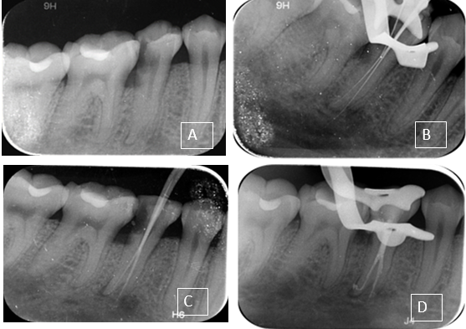
Figure 1: A) preoperative x ray, B) working length, C ) master cone, D) post obturation
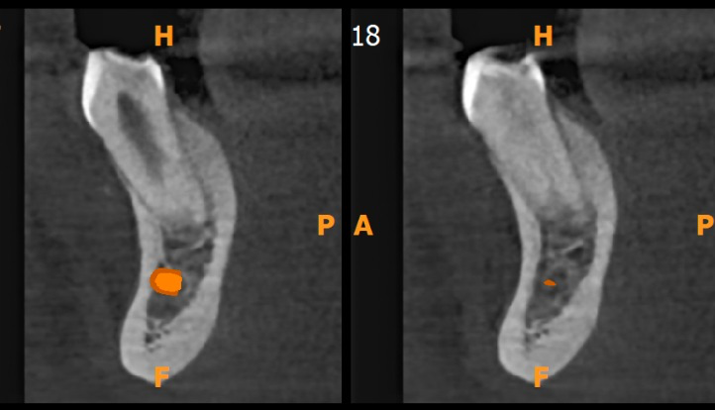
Figure 2: Axial section of CBCT showing root bifurcation

Case Report:
A 35-year-old male patient reported to the department of Conservative Dentistry and Endodontics, Government dental college and hospital, Ahmedabad with pain in lower left back tooth region. Patient had non-contributory medical history. Pain was sharp, shooting, spontaneous and continuous type. Clinical examination revealed carious lesion in distal aspect of left mandibular 2nd premolar. Tooth was tender on percussion. Pulp sensibility test with Electric pulp tester shows early response with lingering type of pain. Intraoral periapical Radiographs showed radiolucency involving enamel dentin and approaching pulp. Widening of the periodontal ligament space was also noted around the root. Bifurcation of the root was suspected in the radiograph so, CBCT analysis was done to confirm. CBCT showed single root bifurcating into two in the middle third, with larger buccal and small lingual root.﻿ Diagnosis of symptomatic irreversible pulpitis with apical periodontitis was made. Root canal treatment was initiated, anesthesia was obtained by means of inferior alveolar nerve block using 1.8 ml of 2% lignocaine hydrochloride with 1:80,000 adrenaline. The tooth was isolated with rubber dam and under 2.5 x magnification all the caries was removed prior to accessing the pulp chamber with number 2 round bur. Using a size 10 K file (Mani dental) canal was negotiated in each of the buccal and lingual root. Biomechanical preparation of both the canals was done with Hyflex CM file system till 25.04 files under 3% hypochlorite irrigation. Calcium hydroxide (CaOH2) intracanal medicament was placed. One week later as the symptoms subsided the root canals were obturated with AH plus (Dentsply) sealer and gutta percha using cold lateral compaction technique. Post-operative Radiograph was taken.
Case 2:
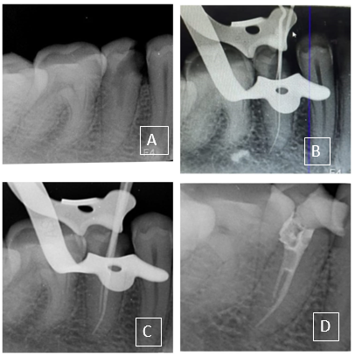
Figure 3: A ) preoperative x ray, B) working length, C )master cone, D) post obturation

A 26-year-old female patient with a non-contributory medical history reported to the department with pain in lower left back tooth region. Pain was of sharp, continuous and lingering type. Clinical examination revealed carious lesion in mesial aspect of mandibular left 2nd premolar. There was no evidence of swelling, sinus tract, and periodontal pocket. Tooth was non tender on percussion. Pulp sensibility test with Electric pulp tester showed early response compared to contralateral tooth. Periapical Radiographs showed radiolucency involving enamel dentin and reaching pulp﻿ in distal aspect of left mandibular second premolar. Abrupt change in size of root canal indicating division of the canals in middle third was noted. Diagnosis of Symptomatic irreversible pulpitis with normal periapical tissue was made. Root canal treatment was initiated, anesthesia was obtained by means of inferior alveolar nerve block using 1.8 ml of 2% lignocaine hydrochloride with 1:80,000 adrenaline. The tooth was isolated with rubber dam & under 2.5 x magnification all the caries was removed prior to accessing the pulp chamber. Coronal third of root canal was enlarged using number 2 Gates Glidden drills. Using a size 10 K file (Mani dental) 2 canals with 1 buccal and 1 lingual were negotiated, working length radiographs confirmed single canal bifurcating in middle third of the root and merging to one canal in apical third. (1-2-1) Vertucci’s type III canal configuration. Buccal canal was relatively straight larger and reaching the root apex. Biomechanical preparation was done till 30.04 in buccal canal and till 25.04 in lingual canal using Hyflex CM file, with 3 % sodium hypochlorite irrigation and dried with paper points. Single sitting root canal treatment was completed using AH plus resin sealer and gutta percha points using cold lateral compaction technique. Post operative radiographs were taken.

Case 3:
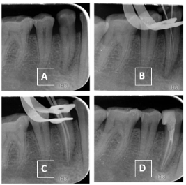
Figure 4: A ) preoperative x ray, B )working length, C )master cone, D )post obturation

A 31-year-old female patient with a non-contributory medical history reported to the department with pain in lower left back tooth region. Patient felt pain on food lodgment. Clinical examination revealed carious lesion in distal aspect of mandibular left first premolar. Tooth was tender to percussion. Pulp sensibility test with electric pulp tester showed no response. Periapical Radiographs showed radiolucency involving enamel dentin and pulp﻿. Widening of Periodontal ligament space was noted. Radiographs revealed abrupt change in the continuity of the root canal anatomy indicating extra canal. Based on signs and symptoms definitive diagnosis of pulpal necrosis with apical periodontitis was made. Root canal treatment was initiated. The tooth was isolated with rubber dam & under 2.5 x magnification all the caries was removed prior to accessing the pulp chamber. Using a size 10 K file (Mani dental) 2 canals were negotiated buccal and lingual, working length taken with stainless steel 10 K file (Mani dental), which showed single canal bifurcating into two canals in the middle third. (1-2 Vertucci’s type V canal configuration).Biomechanical preparation was done till 25.04 Hyflex CM file, with 3% sodium hypochlorite irrigation. Intracanal calcium hydroxide medicament was placed for one week. The root canals were then obturated with AH plus (Dentsply) sealer and gutta percha cold lateral compaction technique. Post operative radiographs were taken.

Case 4:
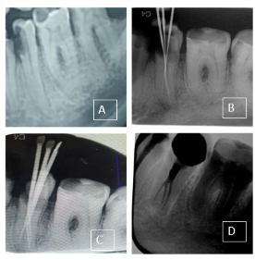
Figure 5: A ) preoperative x ray, B) working length, C) master cone, D )post obturation

A 24-year-old male patient with a non-contributory medical history reported to the department with pain on food lodgment in lower right back tooth region. Clinical examination revealed carious lesion in mesial aspect of mandibular right second premolar. Periodontal pockets around the teeth were within normal limits. Tooth was non tender to percussion .Pulp sensibility test with Electric pulp tester (parkell) was done, which showed no response. Radiographs showed caries involving enamel, dentin and reaching pulp﻿. Careful radiographic evaluation at different angulations showed single root bifurcating into two at the level of middle third. Diagnosis of pulpal necrosis with normal periapical tissue was made. Root canal treatment was initiated. The tooth was isolated with rubber dam & under 2.5x magnification all the caries was removed prior to accessing the pulp chamber. Access opening was done with number 2 round bur. While negotiating canal in buccal root, file was going in two different directions on taking working length radiographs two canals were identified in buccal and one canal in lingual root. Biomechanical preparation of one canal at a time was done with Hyflex CM file system till 25.04 under 3 % sodium hypochlorite irrigation. Calcium hydroxide with 2% chlorhexidine intracanal medicament was placed. One week later as the symptoms subsided the root canals were obturated with AH plus (Dentsply) sealer and gutta percha with cold lateral compaction technique. Postoperative radiographs were taken.
Discussion: ﻿
The possibility of variations in root canal morphology must be considered before root canal treatment is undertaken. Majority of mandibular premolars have single root. Variations include two roots, that are found in 1.8% of these teeth and three-roots in 0.2% cases and four-roots in 0.1% cases, which are very rare^{[2].﻿}Root shape, root position, and relative root outline along with root canals should be carefully examined from the preoperative radiograph. ﻿
At least two radiographs with 15° to 20° horizontal angulations are necessary to diagnose multiple roots/root canals.^{[2]} Along with routine intraoral radiographs use of CBCT allows three-dimensional visualization of aberrant root canal system^{[8].}Use of magnification, careful examination of the floor of the pulpal chamber with endodontic explorer, use of dyes & champagne bubble test are few aids that help in locating extra canals. In case of 2 canals in mandibular premolars locating the lingual canal is more difficult due to lingual inclination of the crown, to counter this situation the clinician may need to extend the lingual wall of access cavity more lingually^{[12]}.Three root canals should be suspected clinically when the pulp chamber does not appear to be aligned in its classic bucco-lingual relationship.^{[10]} In order to achieve success in root canal treatment, it is necessary to identify all existing root canals, do adequate chemico-mechanical preparation and finally, fluid tight seal them with a biocompatible root canal filling material. ^{[1]}
Conclusion:
﻿Latest imaging techniques and evaluation of wider populations have given a better insight regarding mandibular premolar anatomy and their inherent variations. The mandibular premolar teeth might have extremely complex root and canal system morphology, leading to problems during root canal treatment. ﻿It is important for dental clinicians to gain adequate knowledge about the anatomy of the root canal system and its diversities and do proper radiographic evaluations before and during root canal treatment for successful outcome.

References:
- Bodrumlu E, Dinger E. Treatment of anatomic canal variations in premolar teeth: Five case reports. International Dental Research. 2021 Sep 30;11(Suppl. 1):279-84.
- Nouroloyouni A, Lotfi M, Milani AS, Nouroloyouni S. Endodontic Management of a Two-rooted Mandibular First Premolar with Five Root Canals with Cone-beam Computed Tomography: A Case Report. Journal of Dentistry. 2021 Sep;22(3):225
- Robinson S, Czerny C, Gahleitner A, Bernhart T, Kainberger FM. Dental CT evaluation of mandibular first premolar root configurations and canal variations. Oral Surgery, Oral Medicine, Oral Pathology, Oral Radiology, and Endodontology. 2002 Mar 1;93(3):328-32.
- Walker RT. Root canal anatomy of mandibular first premolars in a southern Chinese population. Dental Traumatology. 1988 Oct;4(5):226-8
- Mahalaxmi S, Karthikeyan K, Narayanan A. The probability of canal variations in an individual with extra canals in mandibular first premolar.
- Rödig T, Hülsmann M. Diagnosis and root canal treatment of a mandibular second premolar with three root canals. International endodontic journal. 2003 Dec;36(12):912-9.
- Hajihassani N, Roohi N, Madadi K, Bakhshi M, Tofangchiha M. Evaluation of root canal morphology of mandibular first and second premolars using cone beam computed tomography in a defined group of dental patients in Iran. Scientifica. 2017 Nov 16;2017.
- Kottoor J, Albuquerque D, Velmurugan N, Kuruvilla J. Root anatomy and root canal configuration of human permanent mandibular premolars: a systematic review. Anatomy Research International. 2013;2013.
- Cleghorn BM, Christie WH, Dong CC. The root and root canal morphology of the human mandibular second premolar: a literature review. Journal of Endodontics. 2007 Sep 1;33(9):1031-7.
- Chan KA, YEW SC, CHAO SY. Mandibular premolar with three root canals—two case reports. International endodontic journal. 1992 Sep;25(5):261-4.
- Al‐Fouzan KS. The microscopic diagnosis and treatment of a mandibular second premolar with four canals. International Endodontic Journal. 2001 Jul;34(5):406-10.
- COHEN’S pathway of the pulp 11th Edition. Chapter 5. Page number 190.e1-193.e1
- Thanaruengrong, P., Kulvitit, S., Navachinda, M. et al. Prevalence of complex root canal morphology in the mandibular first and second premolars in Thai population: CBCT analysis. BMC Oral Health 21, 449 (2021). https://doi.org/10.1186/s12903-021-01822-7

